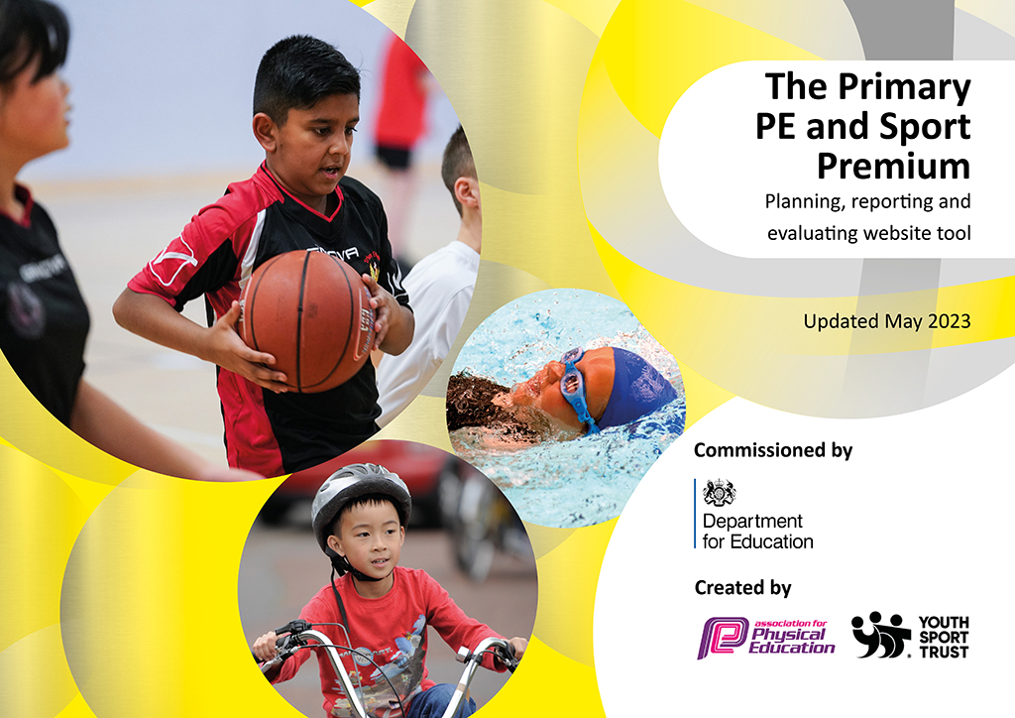
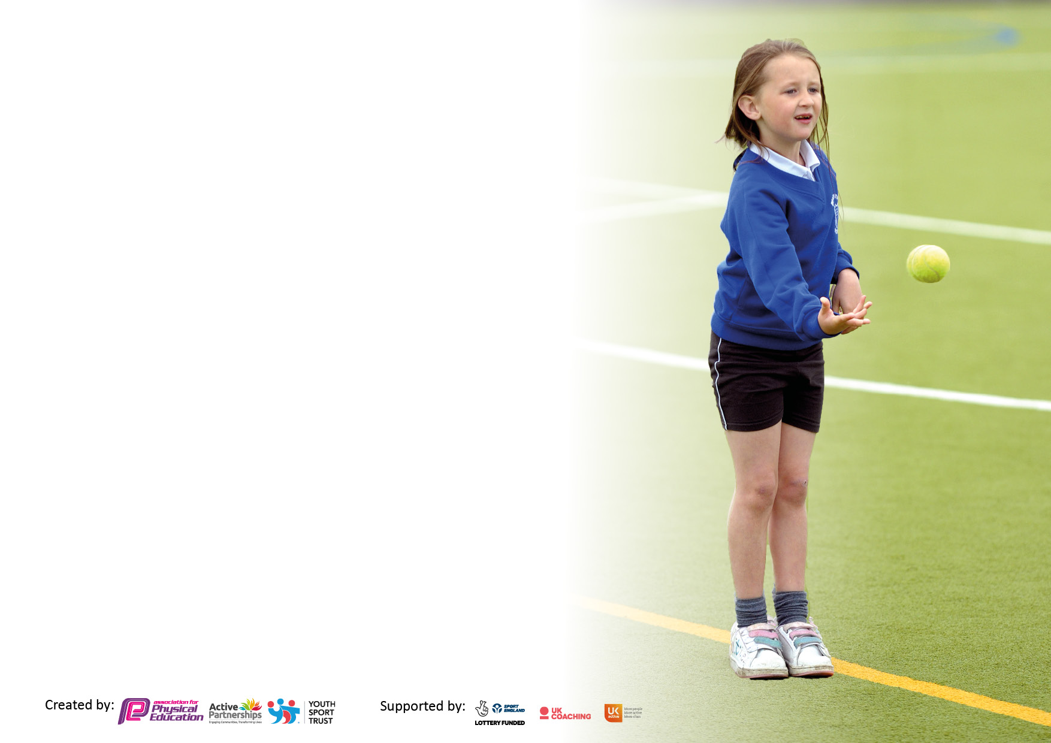

It is important that your grant is used effectively and based on school need. The Education Inspection Framework makes clear there will be a focus on ‘whether leaders and those responsible for governors all understand their respective roles and perform these in a way that enhances the effectiveness of the school’.

Under the Quality of Education Ofsted inspectors consider:
Intent - Curriculum design, coverage and appropriateness
Implementation - Curriculum delivery, Teaching (pedagogy) and Assessment
Impact - Attainment and progress

To assist schools with common transferable language this template has been developed to utilise the same three headings which should make your plans easily transferable between working documents.

Schools must use the funding to make additional and sustainable improvements to the quality of Physical Education, School Sport and Physical Activity (PESSPA) they offer. This means that you should use the Primary PE and sport premium to:

- Develop or add to the PESSPA activities that your school already offer
- Build capacity and capability within the school to ensure that improvements made now will benefit pupils joining the school in future years
- The Primary PE and sport premium should not be used to fund capital spend projects; the school’s budget should fund these.

Please visit gov.uk for the revised DfE guidance including the5keyindicatorsacrosswhichschoolsshoulddemonstrate an improvement. This document will helpyoutoreviewyourprovisionandtoreportyourspend.DfEencouragesschools to use this template as an effective way of meeting the reporting requirements of the Primary PE and Sport Premium.

We recommend you start by reflecting on the impact of current provision and reviewing the previous spend.

Schools are required to publish details of how they spend this funding, including any under-spend from 2021/2022, as well as on the impact it has on pupils’ PE and sport participation and attainment. The funding should be spent by 31st July but the DfE has stated that there will be no clawback of any unspent money so this can be carried forward into 2023/24.

We recommend regularly updating the table and publishing it on your website throughout the year. This evidences your ongoing self-evaluation of how you are using the funding to secure maximum, sustainable impact. Final copy must be posted on your website by the end of the academic year and no later than the 31st July 2023. To see an example of how to complete the table please click HERE.

Details with regard to funding
Please complete the table below.

Total amount carried over from 2021/22 | £2,064.12
Total amount allocated for 2021/22 | £19,018
How much (if any) do you intend to carry over from this total fund into 2022/23? | £18.682.12
Total amount allocated for 2022/23 | £19,082
Total amount of funding for 2022/23. Ideally should be spent and reported on by 31st July 2023. | £37,764.12
Swimming Data
Please report on your Swimming Data below.

Meeting national curriculum requirements for swimming and water safety.

N.B. Complete this section to your best ability. For example you might have practised safe self-rescue techniques on dry land which you can then transfer to the pool when school swimming restarts.
Due to exceptional circumstances priority should be given to ensuring that pupils can perform safe self rescue even if they do not fully meet the first two requirements of the NC programme of study
What percentage of your current Year 6 cohort swim competently, confidently and proficiently over a distance of at least 25 metres?  N.B. Even though your pupils may swim in another year please report on their attainment on leaving primary school at the end of the summer term 2023.  Please see note above | 90%
What percentage of your current Year 6 cohort use a range of strokes effectively [for example, front crawl, backstroke and breaststroke]?  Please see note above | 90%
What percentage of your current Year 6 cohort perform safe self-rescue in different water-based situations? | 30%
Schools can choose to use the Primary PE and sport premium to provide additional provision for swimming but this must be for activity over and above the national curriculum requirements. Have you used it in this way? | Yes/No

Action Plan and Budget Tracking
Capture your intended annual spend against the 5 key indicators. Clarify the success criteria and evidence of impact that you intend to measure to evaluate for pupils today and for the future.

Academic Year: 2022/23 | Total fund allocated: £19,082 | Date Updated: July 2023
Key indicator 1: The engagement of all pupils in regular physical activity – Chief Medical Officers guidelines recommend that primary school pupils undertake at least 30 minutes of physical activity a day in school |  |  |  | Percentage of total allocation:
 |  |  |  | 20%
Intent | Implementation |  | Impact
Your school focus should be clear what you want the pupils to know and be able to do and about  what they need to learn and to  consolidate through practice: | Make sure your actions to achieve are linked to your intentions: | Funding allocated: | Evidence of impact: what do pupils now know and what can they now do? What has changed?: | Sustainability and suggested next steps:
Improve activity levels of pupils during break time opportunities.  Whole school approach to raising activity levels – personal/class challenges, active lessons.  Replenish PE curriculum resources to enhance lessons | Replenish and update equipment.  Continue play leaders for KS1.  Teach active 3 year contract.  Release time for coordinator | £2000 | More active children  Improved social behaviours and interactions  Audit of PE equipment and resources and budget allows ordering of more when necessary.  Children have exposure to active lessons in all areas of the curriculum other than PE | Sustain daily breaktime opportunities for all pupils. Monitor activity levels.  Allocate adult to train and oversee playleaders programme.  Budget to allow for replenishment of equipment.  Lessons are enhanced by correct and well maintained equipment and are therefore challenged and inspired to achieve.
Key indicator 2: The profile of PESSPA being raised across the school as a tool for whole school improvement |  |  |  | Percentage of total allocation:
 |  |  |  | 40%
Intent | Implementation |  | Impact
Your school focus should be clear what you want the pupils to know and be able to do and about  what they need to learn and to  consolidate through practice: | Make sure your actions to achieve are linked to your intentions: | Funding allocated: | Evidence of impact: what do pupils now know and what can they now do? What has changed?: | Sustainability and suggested next steps:
PESSPA linked with active learning- achievement in academic progress but also mental health and well-being.  Link with SENDCo – Sensory interventions increase accommodate more children needing support/an outlet  Promote and celebrate active opportunities in newsletter/website/messages to parents – sporting achievements, gradings and certificates in clubs and out of school.  To continue ‘forest school’ provision across early years and KS1 together with vulnerable group offer to help support well-being and mental health issues.  Extend forest school to incorporate opportunities for OAA and orienteering | Action written in SDP  Teach active resource  Opportunities given to targeted children who need active intervention for their well-being.  More CPD for staff to enable quality interventions.  Forest school expanded and running for more year groups and focus of EYFS and KS1. Ks2 vulnerable group.  New shelter and outdoor classroom | £2,750 over 3 years  £215 coach to cricket  £16,000 forest school salary 2x a week  £52 orienteering packs | All staff are aware of importance, now more than ever, of being physically active, having good health and well-being, link to all areas of achievement.  Promote how active Longfields staff, pupils and families are through website updates, newsletters etc.  Positive impact on behaviour, fitness, and well-being. | Acknowledgement by governors as a standing item on the SDP.  PE governor to work with and to be accountable with PE lead to promote this.  SENDCo to identify targeted pupils.  PE lead to maintain updates to school and wider community so parents are aware of successes and opportunities (such as external visitors)  Continue to evaluate impact of Forest School provision and potential additional groups that may benefit.

Key indicator 3: Increased confidence, knowledge and skills of all staff in teaching PE and sport |  |  |  | Percentage of total allocation:
 |  |  |  | %
Intent | Implementation |  | Impact
Your school focus should be clear | Make sure your actions to | Funding | Evidence of impact: what do | Sustainability and suggested
what you want the pupils to know | achieve are linked to your | allocated: | pupils now know and what | next steps:
and be able to do and about | intentions: |  | can they now do? What has
what they need to learn and to |  |  | changed?:
consolidate through practice:
Partnership with NOSPP  Use of PE lead to model, upskill, offer staff CPD.  Bring other professionals in to offer CPD – Neil Walters Team building days.  Keep current swimming training levels to ensure school is compliant during swimming sessions.  Use of outside coaches to upskill and mentor staff in a range of complimentary and additional sporting activities | Professional teambuilding days which provide CPD for staff and offer pupils a range of outdoor teambuilding activities  PE lead and head to investigate further opportunities for staff training and coaching | £2200 BGN affiliation  £3,195 for 2 days training and equipment | Pupils have access to higher quality first teaching.  Staff are confident to deliver further team-building activities and outdoor activities. Pupils can teach the different teambuilding activities too.  Staff are highly trained to support swimming teaching as part of the curriculum  Staff are highly trained to support PE teaching as part of the curriculum | Teambuilding rolled out across the school, year groups teaching others. Staff have access to the resources purchased.  Swimming training will be taking place £240  Premier education 2 days per week and after school clubs
Key indicator 4: Broader experience of a range of sports and activities offered to all pupils |  |  |  | Percentage of total allocation:
 |  |  |  | 30%
Intent | Implementation |  | Impact
Your school focus should be clear | Make sure your actions to | Funding | Evidence of impact: what do | Sustainability and suggested
what you want the pupils to know | achieve are linked to your | allocated: | pupils now know and what | next steps:
and be able to do and about | intentions: |  | can they now do? What has
what they need to learn and to |  |  | changed?:
consolidate through practice:
Additional achievements:  Increase participation in a broader range of sports and activities.  Broader experience of a range of equipment and activities. | Premier Education providing additional sessions and clubs – Fencing, archery, athletics, rounders, football, tennis.  Equipment for Nursery/EYFS to encourage climbing and balancing.  Footie Kids inflatable pitches and after school clubs offer. | £375 Archery sessions  £1,423.99 | More pupils taking up a range of sports, signing up to after school clubs.  Hard to reach yr ¾ girls targeted by fencing club, high level of participation by girls. Impact statement. | Premier education is already booked in for two days per week next year including after school and lunchtime clubs.  Scooter day planned and booked in. £500

Key indicator 5: Increased participation in competitive sport |  |  |  | Percentage of total allocation:
 |  |  |  | 5%
Intent | Implementation |  | Impact
Your school focus should be clear | Make sure your actions to | Funding | Evidence of impact: what do | Sustainability and suggested
what you want the pupils to know | achieve are linked to your | allocated: | pupils now know and what | next steps:
and be able to do and about | intentions: |  | can they now do? What has
what they need to learn and to |  |  | changed?:
consolidate through practice:
Increase participation in competition opportunities in the wider community (through NOSPP calendared events, liaising with local schools, football team leagues etc)  Ensuring all children have opportunities to experience competition/festivals and they enjoy and succeed at this. | Use NOSPP calendar to decide events, competitions and festivals to attend and for which children.  Maintain football teams – sense of belonging, team plyer, representing the school and themselves | £825.12 | All children will have the chance to compete against themselves, their classmates, part of a team etc.  Enjoyment and success are paramount.  Participation in NOSPP opportunities will increase. | Challenge and competition opportunities will be embedded in the school ethos.  Maintain links with NOSPP and explore more inclusive participation.

Signed off by
Head Teacher: | Claire Rughoobeer
Date: | 17.07.2023
Subject Leader: | Rachel Smith
Date: | 17.07.2023
Governor:
Date:

